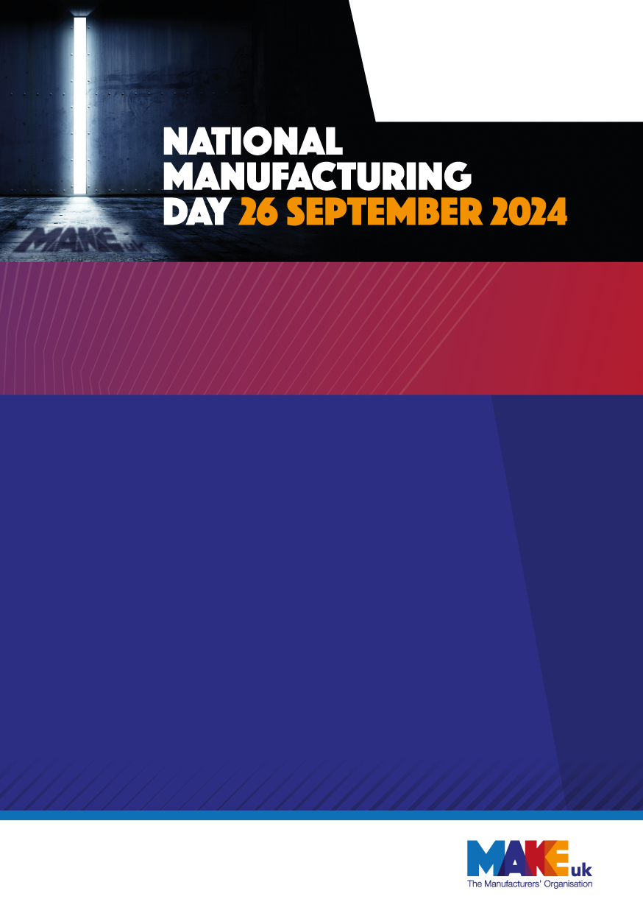

INSERT YOUR LOGO INTO THIS TEXT BOX

[PLACE YOUR COPY HERE] Britain is one of the world's biggest manufacturing nations. Almost 3 million people work in our sector and deliver almost half of all UK exports.
Our companies drive over 60 percent of all UK research and development. As a result of that investment, manufacturing as we know it is changing, adapting, and transforming each and every day.

[PLACE YOUR COPY HERE] On NMD 2022 we will open our doors to members of the public and school children. We will offer tours of our factory and have regular demonstrations of our machinery where guests will have the opportunity ask questions of our staff and apprentices. We will put virtual tour on our website with the opportunity to ask questions for those that can’t make it in person. We will provide information of the school route and further education required to gain employment at a manufacturer’s such as ours.

[Place your title here]
- Information point 1  - Information point 2  - Information point 3  - Information point 4  - Information point 5 | - Information point 6  - Information point 7  - Information point 8  - Information point 9  - Information point 10

Want to find out more and get involved:
[Add copy here if required]
Contact name: [Enter team name or person]
Contact email: [add email address]

